<emdcollection.github.io>

Science Reference

This is basically everything that’s on the exam in some way, since he scrolled through the exam and wrote down every subtopic that was mentioned into the lesson plan. Read this before the exam!

***Chemistry***

**Ionic bonding**

An ionic bond is a bond between two atoms where one atom passes down one or more electrons to another atom. This is done to completely fill or deplete the outer shell of the atoms with electrons. This bond usually happens between a metal and non-metal, and an electron is always taken from the metal and given to the non-metal.

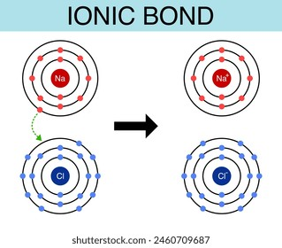

**Reactivity of the periodic table**

For metals, the reactivity increases as the metal is closer to the bottom left of the periodic table. For non-metals, the reactivity increases as the non-metal is closer to the top right of the periodic table. Despite the rules for non-metals, noble gases are still inert, and are generally unreactive.

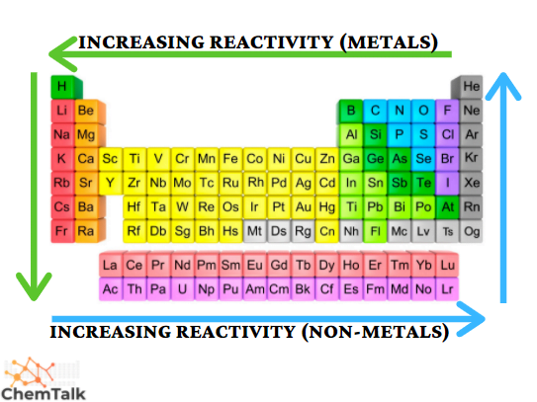

**Groups, periods and trends across the periodic table**

* Groups are the columns of the periodic table.
* Group 1 contains the Alkali metals. They all have one electron in their outer shell, making them have weak metallic bonding.
* Group 2 contains Alkaline Earth metals. These all have two electrons in their outer shell. As such, they are reactive and good at forming compounds.
* Groups 3-12 contain Transition metals. They have properties of metal.
* Group 17 contains Halogens. They are toxic and non-metallic.
* Group 18 contains Noble gases. They are all gases that have a full outer shell. As such, they are unlikely to react (inert).
* Groups 13-16 contain a mix of Post transition metals and Non-metals. They are “divided” by a line of Metalloids which begin in the second period and end in the fifth period. Germanium and Antimony are also included in this “line.” There are only non-metals in groups 14-16.
* Actinides reside in the bottom row below the main portion of the periodic table. They are highly radioactive, ductile, and can be cut easily. On the top row are Lanthanides, which are soft shiny metals. They also dissolve easily and produce a lot of energy when reacting with hydrogen.
  + Lanthanum and Actinium reside in period 6 and 7 of the periodic table in group 3. The rest of the Actinides and Lanthanides share the properties with Actinium and Lanthanum.
* 9 elements in period 7 (Mt, Ds, Rg, Cn, Nh, Fl, Mc, Lv, Ts, and Og) are considered to have unknown properties.
  + As such, Og isn’t a noble gas, Nh to Ts aren’t Post-transition metals, and Mt to Cn aren’t Transition metals.
* Despite being in group 1, Hydrogen is a Reactive non-metal. Its position is based on its electron count.

Below is a graph showing the trends of the periodic table. Note that “character” can be interchanged with “reactivity.”

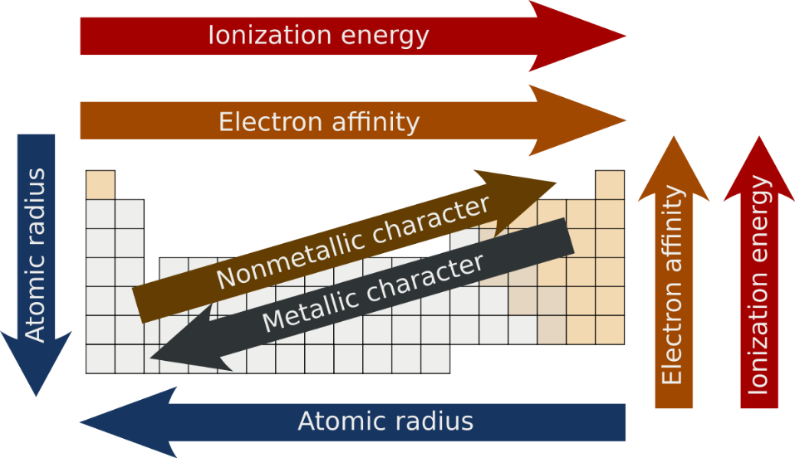

**Covalent Bonding**

A covalent bond is a bond between two atoms where both share electrons to stabilize. This results in the formation of an electron pair/s. See the graph below. Note how the Oxygen atom, which usually has 8 electrons, requires the two extra electrons provided by the two Hydrogen atoms. In graphs, the shared electrons would be shown with an X. This bond usually happens between two non-metals, or a non-metal and metalloid.

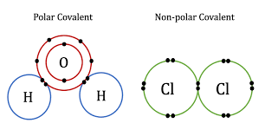

**Writing word equations**

To write a word equation, these steps must be followed:

* The reactants must be on the left side of the arrow, which is pointing to the right, which contains all of the products.
* If multiple compounds are on either side of the arrow, then each is separated by a +.

To further convert the equation as a chemical equation, the following must be done:

* All elements much be converted into symbols.
* (If present) each element should display how many atoms are involved (Oxygen gas would be converted to O2, and the two Oxygen atoms involved are represented by the subscript).
* The coefficient for the compound should also be displayed. This is done with a number in front of the compound, similar to multiplication in maths (O2 is oxygen gas, 2O is two oxygen atoms separate).
* Each reactant and product must have their state in the form of a subscript symbol in a pair of brackets. This is always placed after any subscript numbers).
  + States include (s), (l), (g), and (aq), for solid, liquid, gas, and aqueous respectively.
* The equation must be balanced (the same number of atoms are present in both the reactants and products).

**Balancing equations**

As mentioned, balancing equations is making sure that there are as many atoms in the reactants as there are in the products. To do this, we add coefficients to each of the elements until they are balanced.

As a theoretical example, consider H2 + O2 -> H2O. This equation is not balanced, as there is an additional oxygen atom that isn’t part of the product. The reactants contain one extra atom. To solve this, we can add coefficients to the compounds.

Consider 2H2 + O2 -> 2H2O. This is balanced because there are 4 hydrogen atoms and 2 oxygen atoms on the reactants side and the products side.

**Rates of reaction**

The rate of reaction is the speed at which a chemical reaction occurs. The rate of reaction is the change in concentration divided by the change in time. The rate of reaction varies with different reactions, but certain things may influence the speed.

Temperature can affect the rate of reaction by either slowing it down or speeding it up depending on if the temperature is low or high respectively. Catalysts can also boost reaction rates by reducing the energy required for a reaction to occur. Catalysts aren’t consumed in the reaction, and usually take the form of another substance.

**Types of reactions**

There are various different types of reactions. These includes:

* Decomposition reaction – a compound breaks down into smaller compounds or its elements get separated.
  + AB -> A + B
* Combination reaction – a number of elements combine into one compound.
  + A + B -> AB
* Combustion reaction – a fuel and an oxidant (oxygen) react to produce smoke, water, and heat.
  + CH4 + 2O2 -> CO2 + 2H2O (Methane + Oxygen gas -> Carbon Dioxide + Water)
* Neutralisation reaction – an acid and a base react, forming salt and water.
* Single Displacement reaction – more reactive metal displaces less reactive metals from their salt.
  + AgNO3 + Cu -> Ag + CuNO3
  + AX + B -> A + BX
* Double Displacement reaction – two aqueous ionic compounds exchange their ions and produce two new compounds.
  + AX + BY -> BX + AY
* Precipitation reaction – Two soluble salts are combined to form an insoluble precipitate.
* Redox reaction – a chemical reaction where oxidation and reduction takes place.

**Lewis dot diagrams/electron configurations**

A Lewis dot diagram is a way to express the electrons of an atom. It is written as the symbol of the atom with dots around it representing the electrons on the outer shell of the atom.

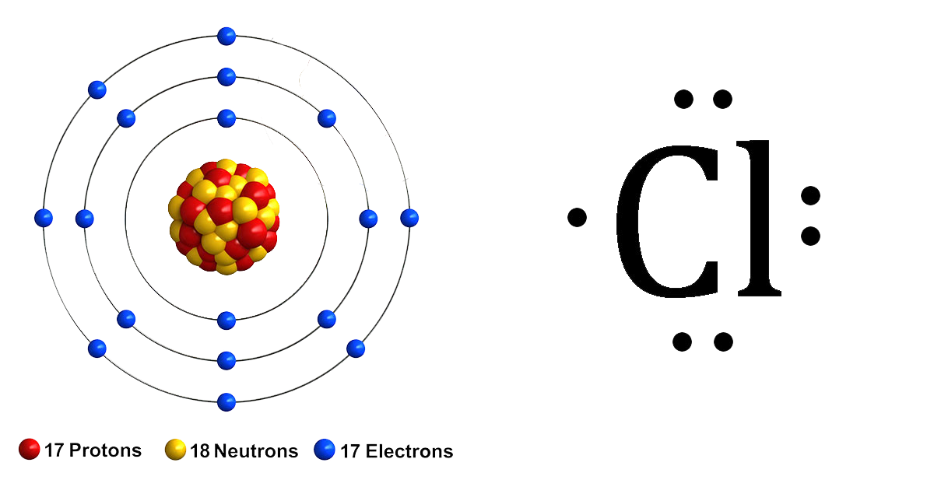

If the atom is an ion, it will have + or – (or 2+, 3- etc) in the top right of the symbol.

***Physics***

**Newtons Laws of Motion**

1. An object at rest remains at rest, and an object in motion remains in motion at constant speed and in a straight line unless acted on by an unbalanced force.
2. The acceleration of an object depends on the mass of the object and the amount of force applied.
3. Whenever one object exerts a force on another object, the second object exerts an equal and opposite on the first.

**Work done***(measured in joules J)*

Work is simply energy transferred to or from an object. Work can only be done if there is a force acting upon an object, and if the object is being displaced. Thus, the formula for work is

Where W is work, F is force, and s if displacement. Work only has magnitude, and no direction. An example of work is a book falling off a table. As the book is freefalling, is has the force of gravity, and it is being displaced from the table to the floor (aka falling).

**Gravitational potential energy***(measured in joules J)*

The gravitational potential energy of an object is the potential energy an object has due to its position in a gravitational field, or more specifically due to its elevation off the ground (usually). Its formula is below:

Where U (or GPE) is the gravitational energy, m is the mass of the object, g is the gravitational force (9.807 m/s2 on earth), and h is the height of the object off the ground. Using the book example from before, the book falls to the ground due to its gravitational potential energy.

**Kinetic energy***(measured in joules J)*

Kinetic energy is the energy transferred to an object due to its motion. This includes voluntary movements like walking, or other movements like falling or being thrown. The formula for kinetic energy is below:

Where KE is kinetic energy, m is the mass of the object, and v is the velocity of the object.

**Crumple zones**

Crumple zones are a feature of cars to keep the driver and passengers in a car safe in the event of a crash. In short, certain sections of the car (namely the front and the back) are made to be able to crumple if they were to crash. This is a way to absorb the energy exerted when the car crashes, as well as slowing down the collision.

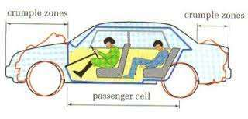

**Airbag protection in car**

Similarly to crumple zones, airbags are used to reduce the effect of the force experience by a person during a crash. In a crash, any passengers including the driver will be thrusted forward, but with an airbag the person is cushioned and the force they received is reduced, meaning the potential damage they receive is also reduced.

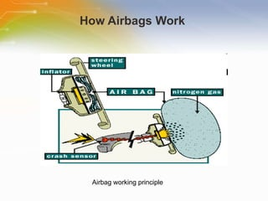

Airbags work by being filled with nitrogen gas once a crash occurs using a crash sensor. Bags are usually directly in front of the driver or passenger.

**Ticket tape timer calculation of velocity**

Ticker tapes are used to see how fast an object is moving, as well as how fast its speed is changing. Take the below example (assume the cart is moving the opposite direction, and that it starts on the right side of the tape).

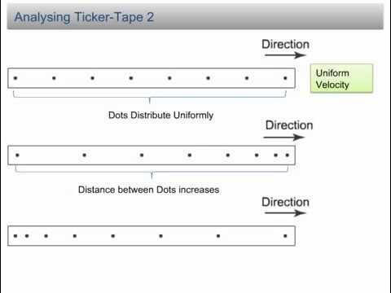

On the first tape, the dots are separated evenly, so the car’s acceleration isn’t changing.

On the second tape, the dots start off close (beginning from the right, where the car would start), but spread out as the tape goes on. Therefore, its speed was changing, because that’s the only way the ticks could change distance, and since the ticks were spreading out more, we know the car’s speed was increasing; the car was accelerating.

The third tape is the same as the second, but in reverse. The ticks start off spread out and slowly bunch up. It’s speed was decreasing, thus it was decelerating.

**Drawing velocity graphs**

A velocity graph is a line graph that allows you to find the velocity of an object given a time and displacement. Remember, the formula for velocity is the displacement over the elapsed time. Since time is independent (we can’t change it), it goes on the x axis, and displacement goes on the y axis.

In a velocity graph, map the points that you already know (“the displacement is this after this amount of time”) and draw a linear or interpreted line linking them.

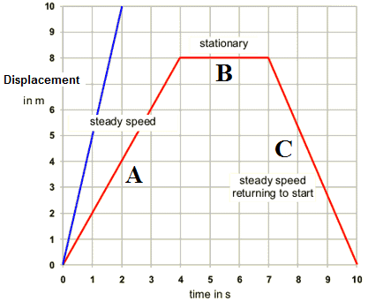

**Velocity***(measured in metres per second m/s)*

Velocity is the speed of an object in a given direction. The formula for v is below:

Where v with a line over is the average velocity, d is displacement, t is time, and the triangle indicates a change. Displacement is just how far the object is from its origin, compared to how far the object has travelled at all.

**Acceleration***(measured in metres per second squared m/s2 or ms-2)*

Acceleration is the rate at which the speed of an object is increasing. If an objects speed is not changing, then it is not accelerating. The formula for acceleration is below:

Where a with a line over is the average acceleration, v is velocity, t is time, and the triangle indicates a change.

***Cosmology***

**Big Bang**

The Big Bang is a theory that describes how the universe was created out of a singularity, a single point where all of the energy of the universe was concentrated to. After a significantly short amount of time, time and space begun and the universe was expanding. After some time, subatomic particles began to form, and their energy produced light, although they were still too fast to combine into atoms. After a couple of minutes of cooling, hydrogen, helium, and lithium nuclei formed. 300,000 thousand year later, nuclei were connecting with electrons, and all the light escapes, and the universe was dark. Further nuclear reactions and fusions lead to the formation of stars.

**Hertzsprung-Russell diagram**

This scatterplot was made to identify the classification of stars using their surface temperature (measures in Kelvin, 3000 K is 2726.85 C) and luminosity (the amount of energy radiated from a star per second, energy measured in joules).

The diagram is useful for tracing the evolutionary stage of a star. This diagram also let scientists identify that the life of a star made them move in regular patterns around the Hertzsprung-Russell diagram.

**Nebula**

Nebulae are giant clouds of dust and gas in space. Stars are born when the nebula collapses, as pressure from gravity allows a star to be born sometime in the future. Nebulae are made when gas and dust are thrown out by dying stars like supernovas. A supernova is the powerful explosion made by a dying star.

**Light year**

A light year is the distance light can travel in one year. A light year is about 9.46 trillion kilometres. This is because light can travel 9.46 trillion kilometres in a year.

**Red Shift**

Because elements each have a specific spectrum, scientists can tell what a star is made of by their spectrum. When the observed spectra (plural for spectrum) of stars a shifted towards the red or blue end of the spectrum, the motion of the object is emitting radiation. This is the Doppler Effect, or Red/Blue Shift. An object moving towards earth would have a blue Doppler shift, and an object moving away from earth would have a red Doppler shift. The farther a galaxy is from earth, the greater the red shift, indicating that the rate of expansion of the universe is increasing.

This is used to explain that the universe is expanding, rather than moving away due to previous explosions. This explains why objects spread out more as the universe expands.

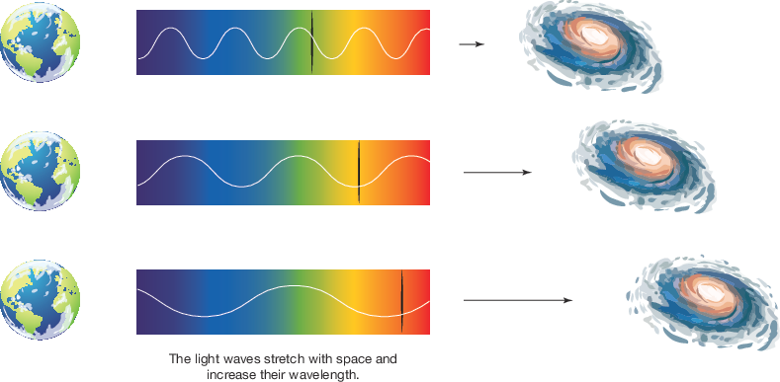

**Spectroscopy**

Spectroscopy is the study of the absorption and emission of light and other radiation by matter. It involves splitting light into its wavelengths. Like an optical prism splitting a white light into all of its different colours, Spectroscopy splits light into all of its different wavelengths.

**Parallax effect**

Parallax effect is objects around the observer appearing to move at different distances, an effect caused by the movement of the observer themselves. As the earth orbits the sun, the position of the stars change slightly in relation to each other. If all of the stars were the same distance from earth, this wouldn’t happen. The parallax effect indicates that some stars are much closer to us than others. Below is a simplified example of the effect:

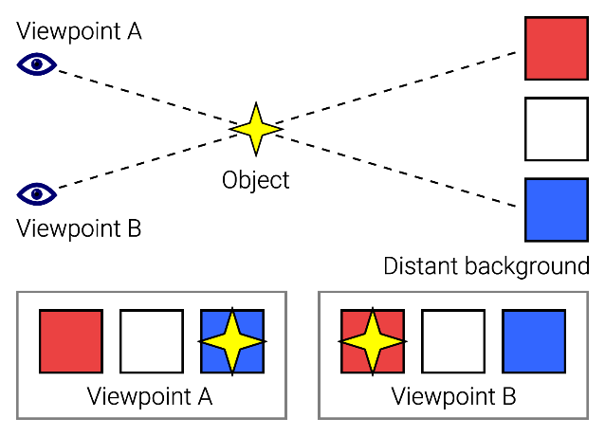

**Formation of the stars and planets**

As dust and gas from a nebula collapse, pressure from gravity can cause a star to be born.

As stars are being formed, extremely hot winds are being ejected, causing atoms to fall on the star. While most fall on the star, some escape it and/or crash into one another, clumping up. This clump gets bigger and bigger, either breaking up or holding on. These create planetesimals, the building blocks of planets. After millions of years, a planet is formed out of this.

Further from the star are fragments of ice which travel with the dust of the star. Like before, these can amass into giant planetary cores. They also allow gas molecules to be drawn to the planet, which is how gas giants are formed.

**Energy production in stars**

Stars undergo a process called nuclear fusion. This occurs when the nuclei of atoms squeeze together to form another element (two hydrogen becoming helium). This process releases energy and heats the star up too, which prevents it from further collapsing.

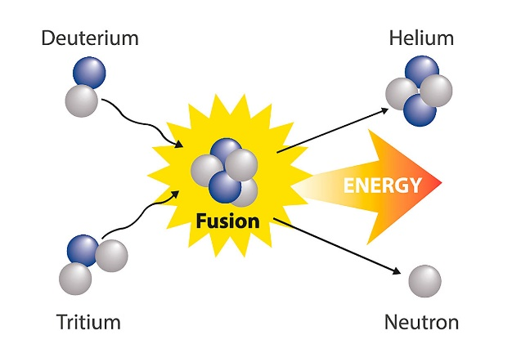

Deuterium and Tritium are names describing how many subatomic particles are present in a nucleus

**How are satellites used in modern society**

Satellites are machines that send signals from a source to a receiver. They are located in space close to earth. A satellite receives radio signals sent from earth and sends them back down to earth to a receiver. This mode of communication has allowed satellites to serve many useful functions, including:

* Navigation - Allowing people to determine their location. Also used for signalling trains and aircraft, as well as emergency services.
* Communication – Allowing people to communicate with each other remotely. It also allows the communication of TV programmes.
* Weather – Meteorologists are provided with a global weather overview.
* Environment – Satellites can observe wildfires, volcanoes, smoke, and other environmental incidents.
* Space Exploration – Satellites can explore stars, planets, asteroids, and comets.
* Defence – Military organizations and defence use satellites for accurate, real-time guidance for weapons systems and aircraft.
* Satellites are also used to communicate important information, like transaction information being sent to a bank.